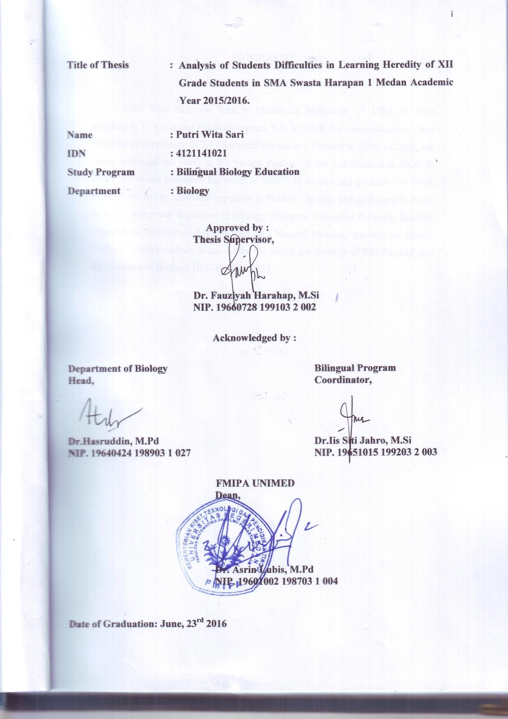

**BIOGRAPHY**

Putri Wita Sari was born in Medan on September 1st 1994, the first daughter of Ir. Ku’at and Haida Dongoran, S.E. In 1998, the writer started her first educational experience in TK Pancabudi Medan and finished in 2000. In 2000, the writer continued her study in SD Swasta Pertiwi Medan and finished in 2006. In 2006, the writer continued her study in SMPN 38 Medan and graduated in 2009. In 2009, the writer continued her study in SMAN 3 Medan and graduated in 2012. In 2012, writer was registered in Biology Bilingual Education Program, Biology Department, Faculty of Mathematics and Natural Science, Universitas Negeri Medan. During her study in university, the writer is a member of BIOTA, and also the secretary of Biology HMJ in 2014-2015.