GENDER SPEECH ACTS IN ISLAMIC EDUCATION DEPARTMENT
CLASS AT STATE ISLAMIC INSTITUTE (IAIN)
OF ZAWIYAH COT KALA LANGSA

A Thesis

Submitted to the English Applied Linguistics Study Program in Partial Fulfillment of the Requirements for the Degree of Magister Humaniora

By
NANDA MARLINA AS
Registration Number: 8156112055

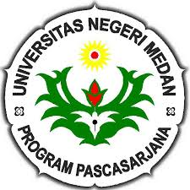

ENGLISH APPLIED LINGUISTICS STUDY PROGRAM
POSTGRADUATE SCHOOL
STATE UNIVERSITY OF MEDAN
MEDAN
2017

